SC practice and HM questions

· Given

i. CvD

ii. ~H=(AA~B)

iii. (CvD) =~ H

iv. (AA~B) => (R v S)

Can (R v S) be inferred from the above?

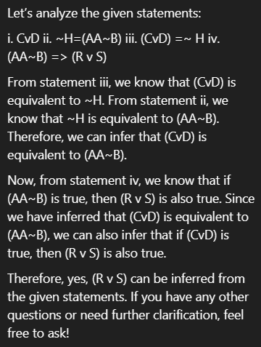

QUESTION: Translate the following English

sentences into predicate logic formula.

a. John likes Susan.

b. John has a cat.

c. A whale is a mammal.

d. Barking dogs don't bite.

e. Either every fruit is bitter or every fruit is sweet.

f. Every student heard some news. (possibly different news for

each student)

g. There is some news that every student heard.

h. No student likes any exams.

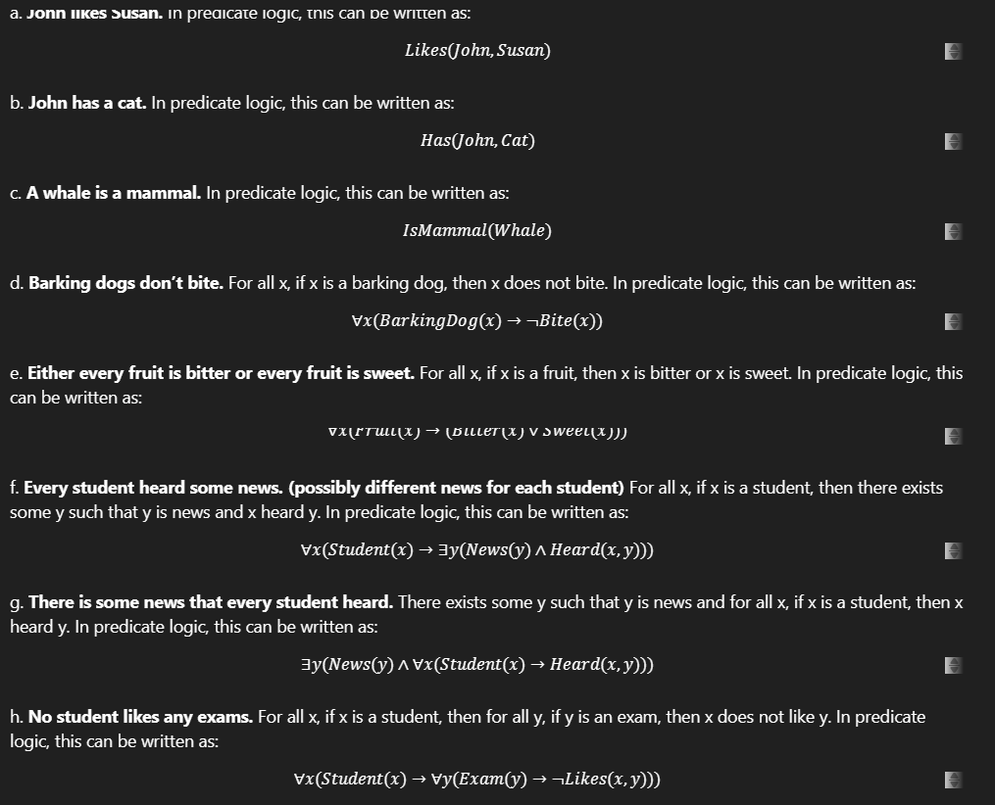

· Write predicate logic statements for-

i. Ram likes all kinds of food

ii. Sita likes anything which Ram likes

iii. Viraj likes those which Sita and Ram both like

iv. Ali likes some of which Ram likes

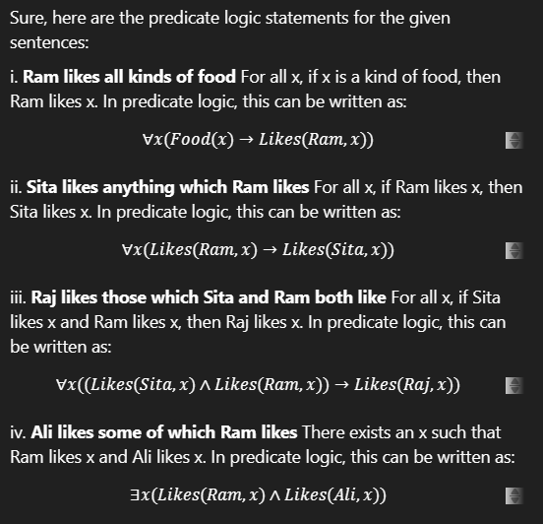

i. Every soldier is strong-willed.

ii. All who are strong-willed and sincere will

succeed in their career.

iii. Indira is a soldier.

iv. Indira is sincere.

Prove "Will Indira succeed in her career?"

